Warsaw, 20.07.2026

Tilda Swinton – Ongoing. A unique exhibition created by one of the most influential figures in contemporary culture comes to Poland for the first time
This autumn, Malta Festival invites the Polish public to Warsaw to see Tilda Swinton – Ongoing, one of the most remarkable international exhibition projects of recent years. The exposition will be open to visitors from September 18, 2026, to January 17, 2027, at the newly opened space of the Institute of Creative Industries (former printing house of the Polish Press Agency – PAP).
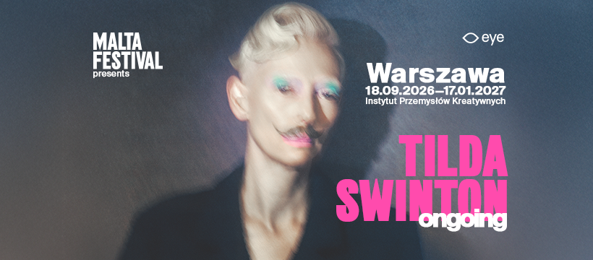
The exhibition marks the next chapter in the collaboration between Malta Festival and the acclaimed Scottish actress, performer, artist and style icon Tilda Swinton. In 2025, her performance Embodying Pasolini, created alongside Olivier Saillard, was presented in Poznań. Following its success at the Eye Filmmuseum in Amsterdam and at Onassis Ready in Athens, the Ongoing project is now coming to Warsaw. It will be showcased in a space arranged by architect Maciej Siuda, created specifically for the Creative Industries Institute building at 65 Mińska Street.
Tilda Swinton is an Academy Award and BAFTA winner, as well as the recipient of numerous prestigious film accolades. A graduate of the University of Cambridge in Social and Political Sciences, Swinton began her acting career in Edinburgh, performing with the Royal Shakespeare Company, among others. For more than four decades, she has remained one of the defining figures of contemporary cinema, collaborating with filmmakers including Wes Anderson, Sally Potter, Lynne Ramsay, Jim Jarmusch, Pedro Almodóvar, Joanna Hogg and Luca Guadagnino.

More than a retrospective: a celebration of collaboration and friendship
Tilda Swinton – Ongoing is not a traditional retrospective or a biographical narrative of a single individual. Instead, it is an exhibition about creative relationships, collaborations and the mutual inspirations between the artist and those around her. The exhibition's point of departure is the conviction that art never arises in isolation; rather, it is born from encounters, dialogue, trust and collective action. Archival materials meet new works created specifically for this project, while the title Ongoing serves as a reminder that creativity does not end with a film premiere or the closing of an exhibition – it continues to evolve through future encounters, conversations and collaborations.
“I particularly did not want to create a retrospective,” explains Tilda Swinton. “I am interested in the process that is still unfolding. 'Ongoing' is an attempt to map the creative relationships that have shaped - and continue to shape - my life for over 40 years: the conversations, friendships and collaborations from which films and projects are born. This is why I am particularly thrilled that the exhibition is coming to Poland – a country with a remarkable cinematic history and creative courage, whose culture has inspired artists worldwide for generations. I hope that here, too, 'Ongoing' will become the starting point for further conversations and new encounters, encouraging emerging artists to realise that the power of making work rooted of the fellowship of friendship is something we never need to abandon or fail to be nourished by” she adds.

Featured works and themes
While Swinton remains the central figure of the exhibition, the true heroes of the event are the artists with whom she has co-created films, performances and art projects over the decades. Among them are Pedro Almodóvar, Luca Guadagnino, Joanna Hogg, Derek Jarman, Jim Jarmusch, Olivier Saillard, Tim Walker, Sandro Kopp and Apichatpong Weerasethakul. Each contributor shapes the exhibition with their own artistic language, demonstrating that cinema can be a space for friendship, dialogue and a collective search for new forms of expression.
The exhibition features films, photographs, installations, objects, archival materials and pieces commissioned specifically for this project. Visitors will experience Joanna Hogg’s new installation Flat 19, Apichatpong Weerasethakul’s film work Phantoms, Luca Guadagnino’s Camaraderie, Olivier Saillard’s fashion installation A Biographical Wardrobe, as well as a presentation dedicated to the legendary performance The Maybe - one of the most seminal projects in Tilda Swinton's career.
The themes embedded in Ongoing: community, friendship, care, memory, creative independence and a female perspective, have long resonated with the core programming of Malta Festival. Presenting the exhibition in Warsaw is a natural extension of the festival’s mission to consistently create space for international projects that cross the boundaries between artistic disciplines.
“There are projects that transcend the boundaries of a single discipline and a single location,” admits Dominika Kulczyk, patron of Malta Festival. “‘Tilda Swinton – Ongoing’ is precisely such an endeavor. It speaks of collaboration as the most precious value in both art and life – of relationships that, over time, become a source of courage, imagination and new ideas. These values are deeply aligned with Malta Festival. I am proud that after Amsterdam and Athens, we can invite the Polish public to experience this extraordinary narrative in Warsaw, joining the international journey of one of the most significant exhibition projects of recent years.”
Ongoing also stands out for its scale and perspective. It is one of the few exhibitions worldwide of this magnitude dedicated to a single performer and film artist, structured not around the chronology of a career but around a network of creative relationships and co-authored works. Instead of a biography, the curators offer a narrative about the creative process itself and the meaningful encounters behind it.

A new opening in a post-industrial space
The Warsaw edition of the exhibition will take place in the exceptional, post-industrial space of the Institute of Creative Industries (former printing house of the Polish Press Agency – PAP). This is the first venture of its kind and scale to be realized in this venue.
It is worth noting that both the Amsterdam and Athens iterations of Ongoing were mounted within adapted exhibition spaces in established museum institutions. Warsaw, by contrast, blazes a new trail by presenting Ongoing in an entirely raw, newly designated space. The adaptation of the exhibition across approximately 1,000 square meters has been prepared by the award-winning architect Maciej Siuda. His design introduces intriguing structural solutions that emphasize the unique character of the venue and draw on its potential – one could say that the ICI space is an inspiration in its own right.
The organizer of the exhibition Tilda Swinton – Ongoing is Malta Festival – one of the most important and highly recognized cultural festivals in Poland, under the patronage of Dominika Kulczyk. For over 35 years, the festival has been setting the direction of contemporary culture, combining theater, dance, music, film, and performing arts, while presenting key international projects and outstanding artists from all over the world.
The exhibition Tilda Swinton – Ongoing will be open to the public from 18 September 2026 to 17 January 2027 at the Creative Industries Institute (Instytut Przemysłów Kreatywnych) premises on 65 Mińska Street in Warsaw.
Press materials (including photos and photo credits, promotional videos, and graphic assets) are available for download HERE.
Media contact:
Dominika Baranowska | PR and Communication Manager
mob: +48 536 262 986
e-mail: dominika.baranowska@malta-festival.pl

